**Suivi de projet**

Diagramme de Gantt :

<https://wizzinv-my.sharepoint.com/:x:/g/personal/rebecca_houitte_wizzinv_onmicrosoft_com/EdfDWiafzJ9EjzS8xlZov7MBMalR2-3remLSj3B90w7ENQ?rtime=iK2yGisq3Eg>

Compte rendu de réunions : <https://docs.google.com/document/d/10YPlhsaoFpq5vNe4dwaxcmGjjsqYggS4p_JkPYyeT5M/edit>

**Mediapipe**

* Geste recognition

Demo : <https://mediapipe-studio.webapps.google.com/demo/gesture_recognizer>

Guide : <https://developers.google.com/mediapipe/solutions/vision/gesture_recognizer#models>

Example : <https://colab.research.google.com/github/googlesamples/mediapipe/blob/main/examples/customization/gesture_recognizer.ipynb#scrollTo=aTTNZsolKXiT>

* Hand landmark detection

Demo : <https://mediapipe-studio.webapps.google.com/demo/hand_landmarker>

**Guide** : <https://developers.google.com/mediapipe/solutions/vision/hand_landmarker>

**Hand detection Model**

* Keypoint detection benchmark articles : <https://paperswithcode.com/task/keypoint-detection>
* Article bootstrapping <https://arxiv.org/pdf/1704.07809.pdf>

modèle basé sur l’article : <https://github.com/erezposner/MV_HandKeyPointDetector?tab=readme-ov-file>

* **hand tracking** : <https://github.com/victordibia/handtracking> (using tensorflow ssd_mobilenet_v1_coco model with transfert learning to detect hand)

gesture recognition using hand tracking <https://github.com/zzeitt/forGestureRecognition>

* Kaggle mediapipe shifumi project : <https://www.kaggle.com/datasets/aryan7781/stone-paper-scissors-hand-landmarks-dataset/code>
* Kaggle CNN shifumi classifier project : <https://www.kaggle.com/code/aradbenmenashe/rock-paper-scissors-classification-97-9-acc>

**Datasets**

* Données main **Egohands** : 48x100, pas téléchargeable

<https://vision.soic.indiana.edu/projects/egohands/>

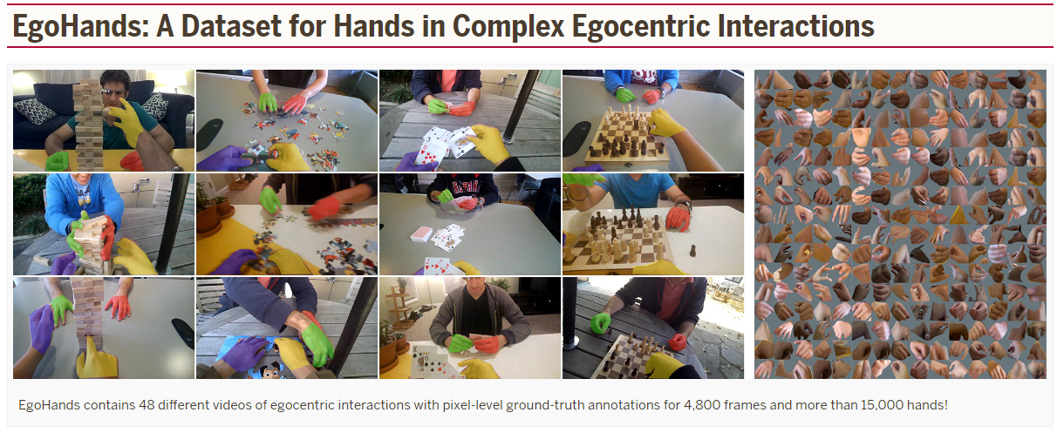

* Données main **Jester** : webcam, 5 millions existants, 2.3m téléchargeables, fond / éclairage / acteur variés

Kaggle <https://www.kaggle.com/datasets/toxicmender/20bn-jester?select=Validation>

Article <https://openaccess.thecvf.com/content_ICCVW_2019/papers/HANDS/Materzynska_The_Jester_Dataset_A_Large-Scale_Video_Dataset_of_Human_Gestures_ICCVW_2019_paper.pdf>

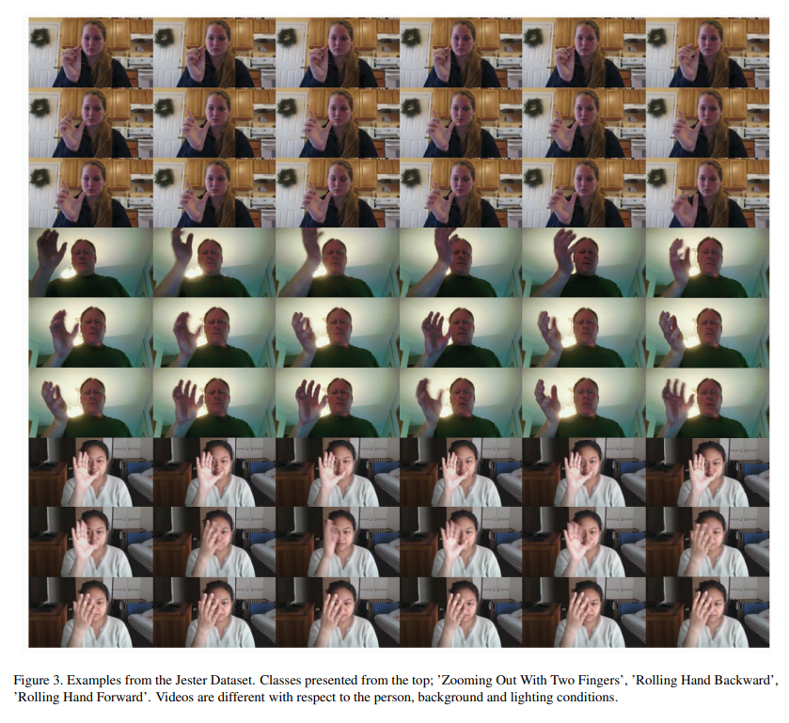

* BDD mains shifumi : 2189 images réelles

<https://www.kaggle.com/datasets/drgfreeman/rockpaperscissors?select=rock>

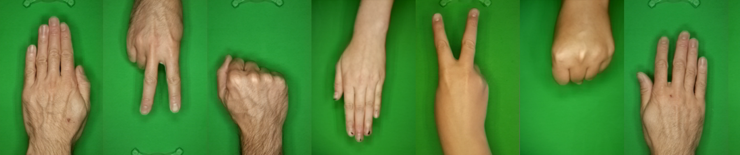

* Données main Shifumi : 2925 image de synthèse <https://www.kaggle.com/datasets/sanikamal/rock-paper-scissors-dataset>

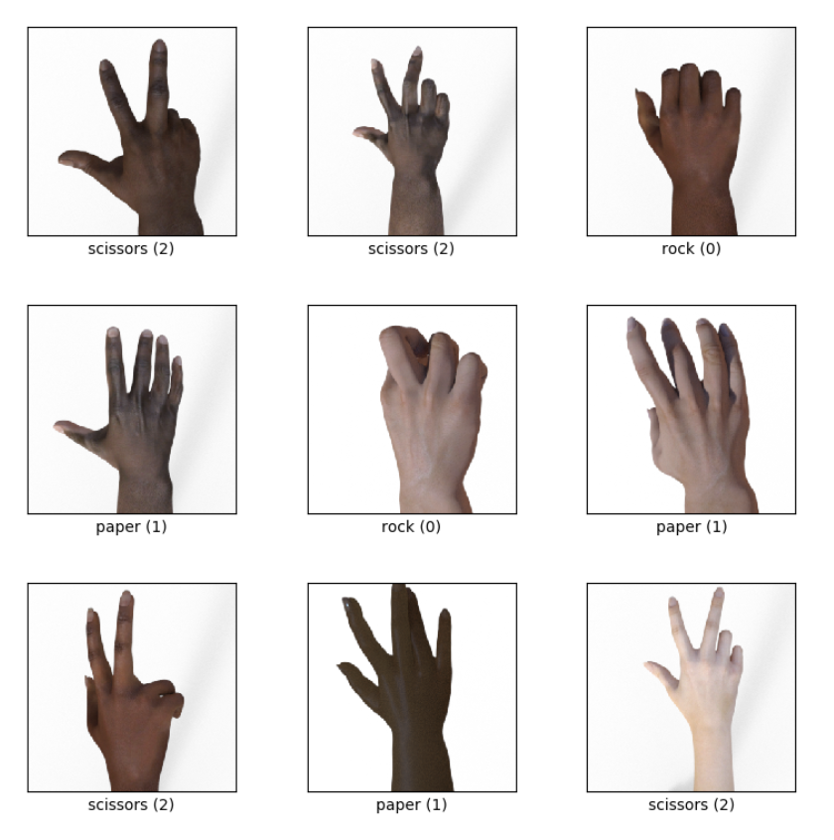

* Augmentation de données avec conservation de landmarks : <https://imgaug.readthedocs.io/en/latest/source/examples_keypoints.html>
* 11k hand open and close palm : <https://sites.google.com/view/11khands>
* 2100 images main : <https://www.kaggle.com/datasets/ritikagiridhar/2000-hand-gestures>